MODULE 1-4

1. Install VirtualBox or VMware. Set up a virtual machine with any Linux distribution (preferably Kali Linux).
- Screenshot Submission: Screenshot of VirtualBox/VMware with the virtual machine running.
Ans:
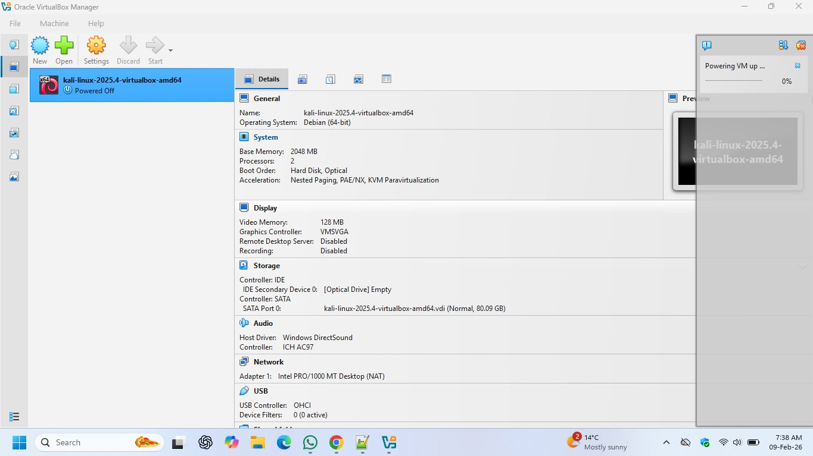

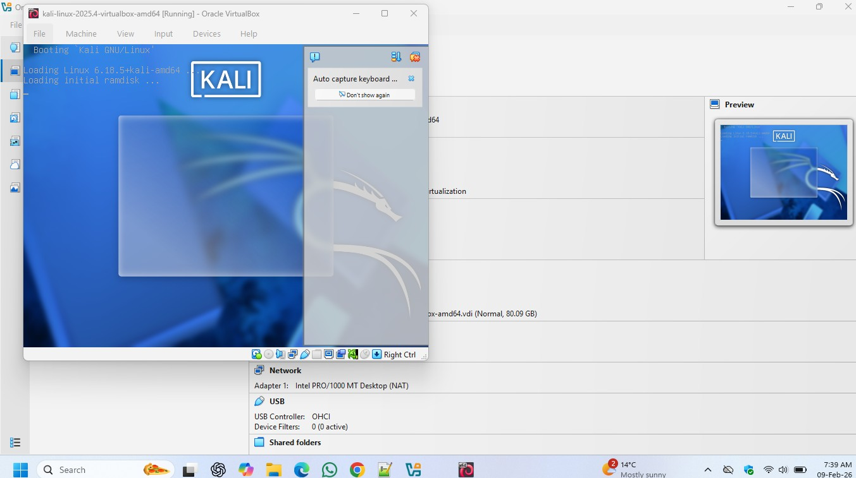
2. Install Kali Linux in your virtual machine and update it..
- Screenshot Submission: Screenshot of the terminal showing the completion of the update.
Ans:
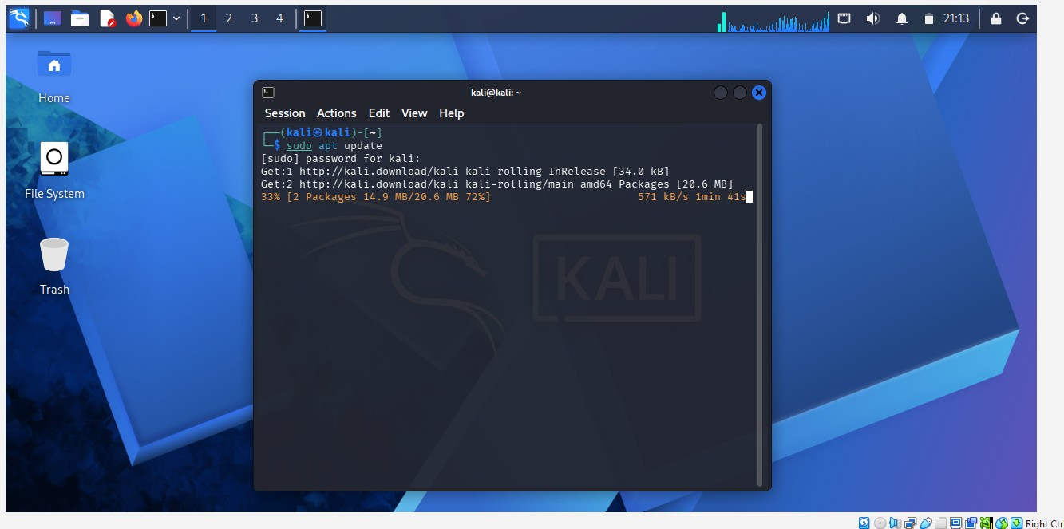

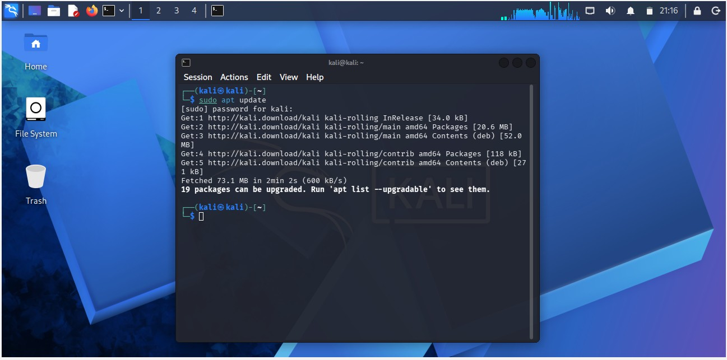

3. Explore the applications menu in Kali Linux. List 5 tools and their purpose.
- Screenshot Submission: Screenshot of the applications menu.
Ans:
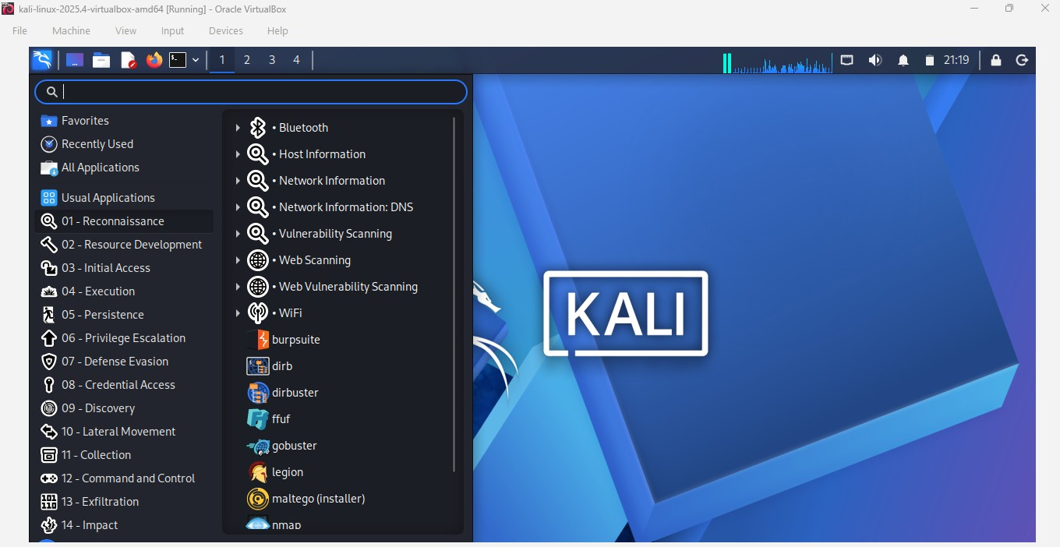
1. Nmap
Category: Information Gathering
Purpose:
Nmap (Network Mapper) is used to scan networks and discover live hosts, open ports, services, and operating systems.
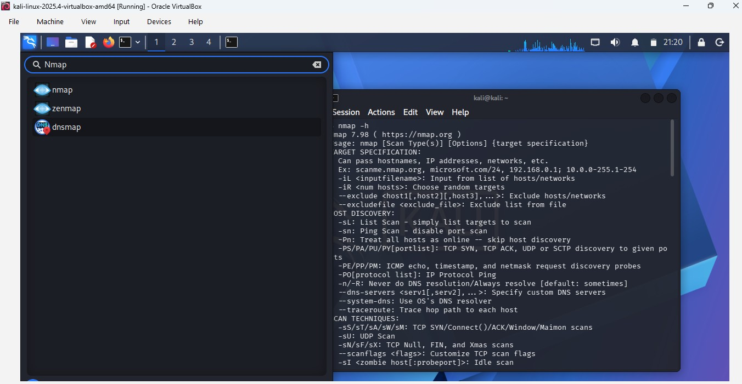

2. Wireshark
Category: Sniffing & Spoofing
Purpose: Wireshark is a packet analyzer used to capture and analyze network traffic in real time.
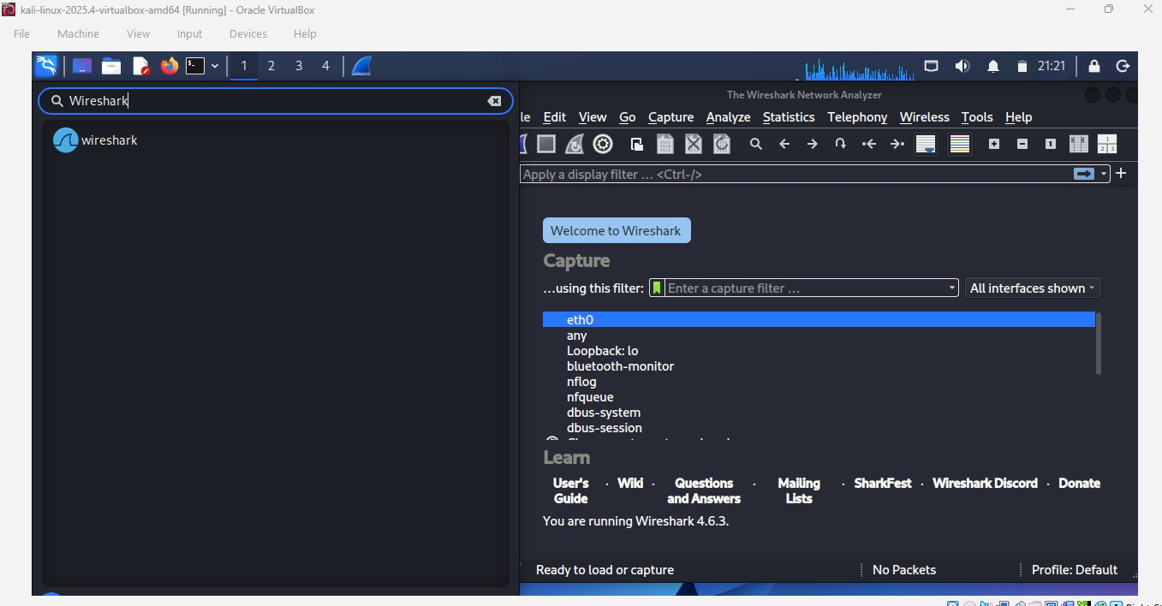

3. Metasploit Framework.
Category: Exploitation Tools
Purpose: Metasploit is used to find and exploit vulnerabilities in systems and applications.
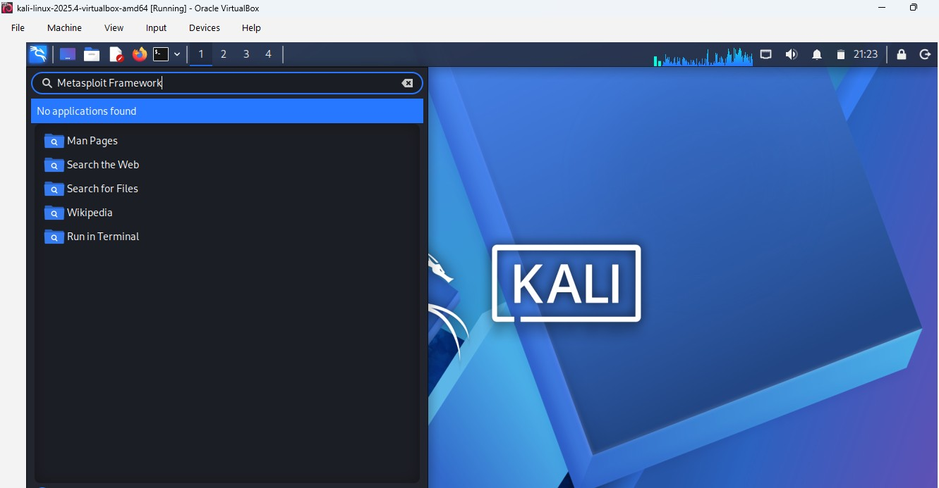

4. John the Ripper
Category: Password Attacks
Purpose: John the Ripper is used to crack passwords using different attack methods like brute force and dictionary attacks.
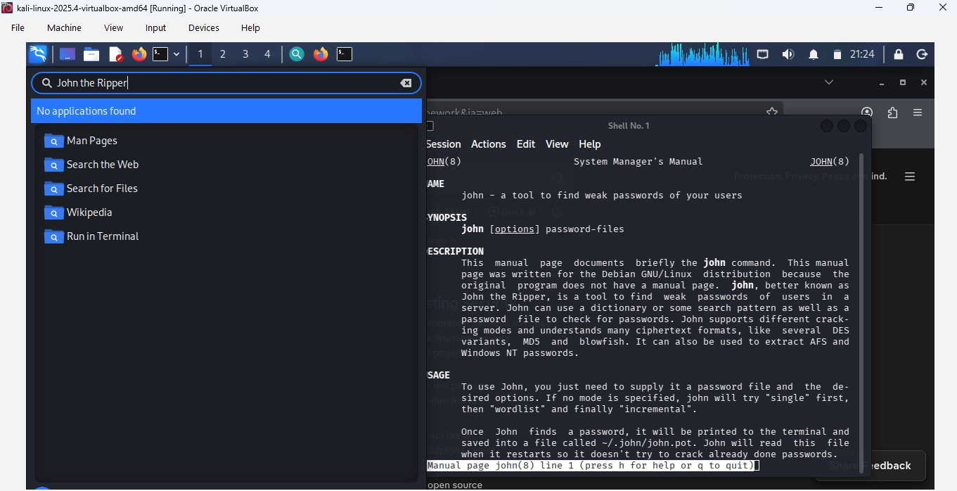

5. Burp Suite
Category: Web Application Analysis
Purpose:
Burp Suite is used to test the security of web applications by intercepting and analyzing HTTP/HTTPS traffic.
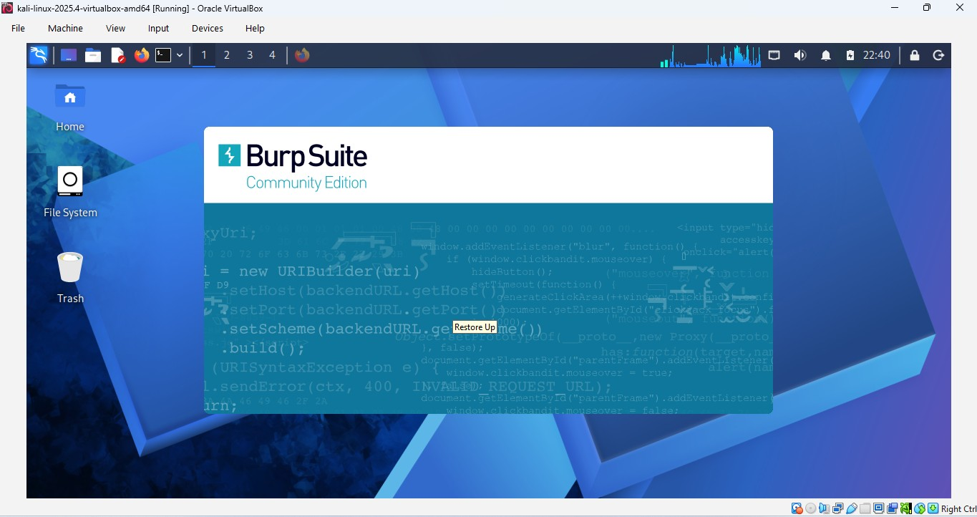

4. Execute the following Linux commands:
- Find command
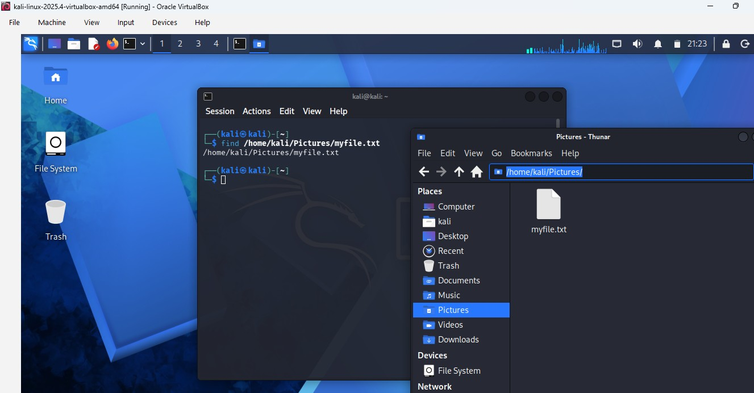
- Ping command.
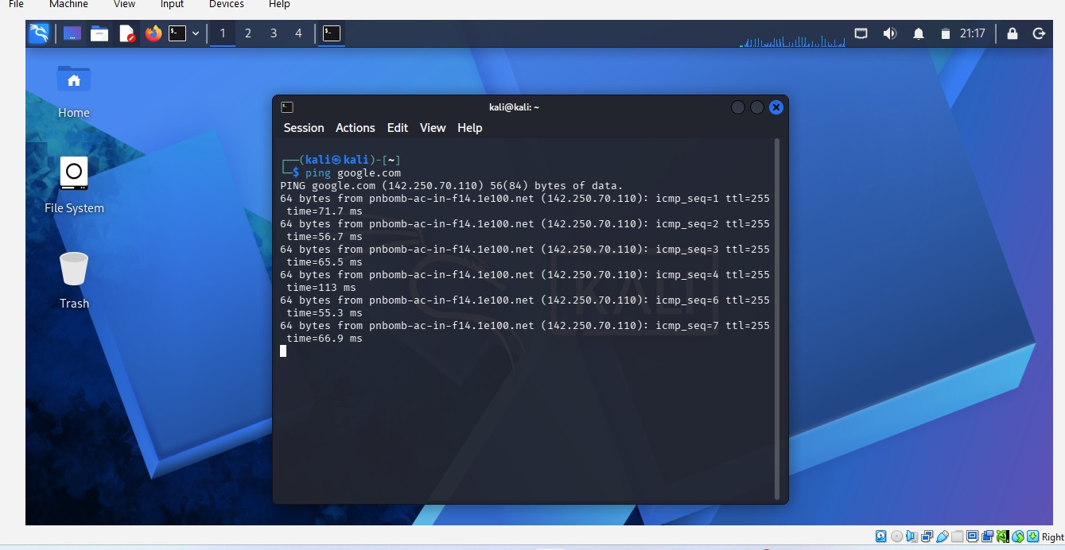

- Traceroute command.
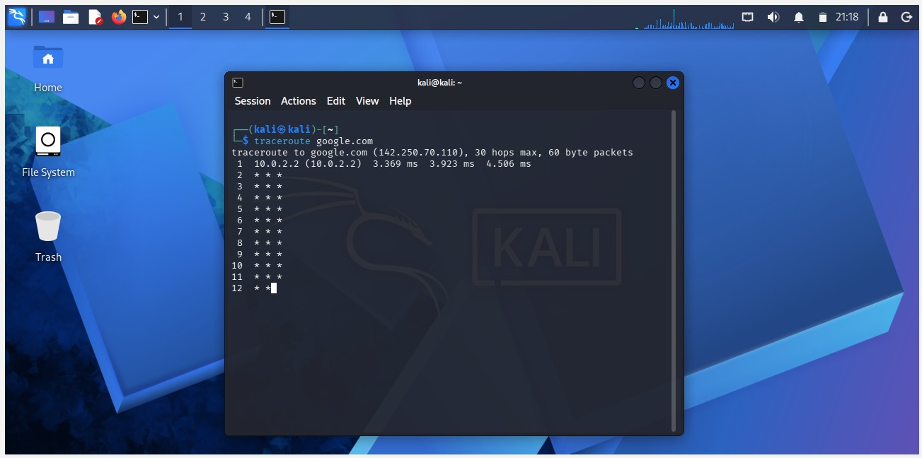
- Whoami command.
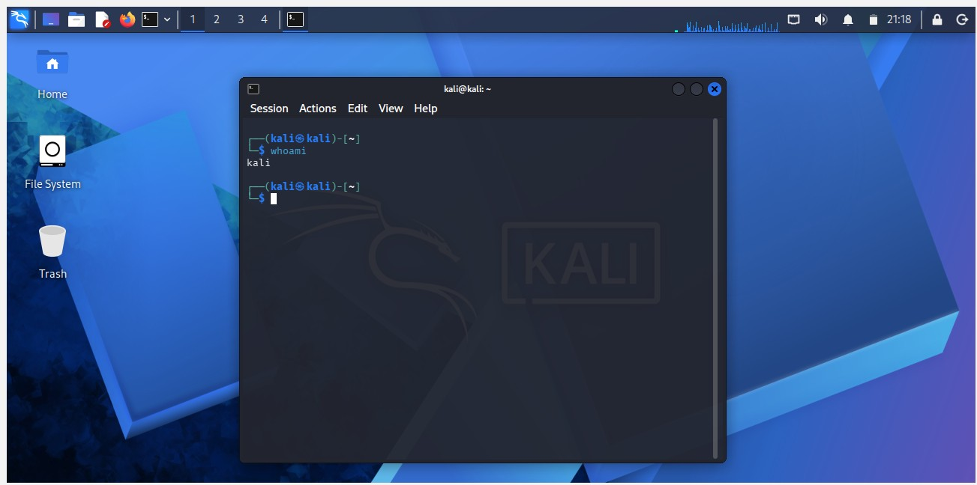

- Ps command.
